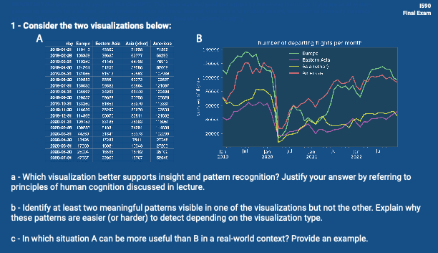
YOUR RESPONSES

a.
Visualization B is better for seeing patterns and trends because it shows changes over time in a clear way. Our brain finds it easier to follow lines and spot drops or rises than to compare numbers in a table.
b.
In B, it’s easy to see the big drop in flights around early 2020 and the slow recovery after that. Both of these changes are hard to notice in A because you'd have to read and compare each number one by one.
c.
A is more useful when you need to find exact numbers, like checking how many flights happened on a specific day. It’s better for tasks like reports or data checks where accuracy matters more than patterns.
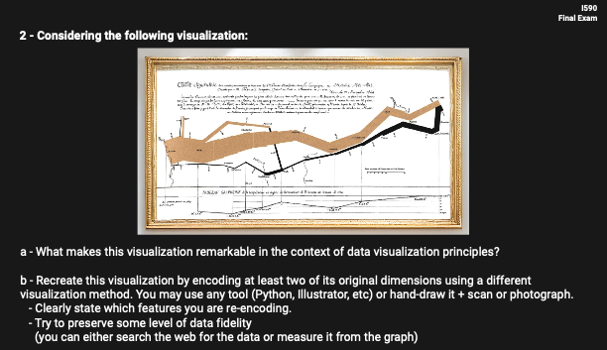
YOUR RESPONSES

a.
This visualization is remarkable because it tells a powerful story using multiple data aspects like location, time, direction, and number of survivors are all shown at once. It’s a great example of how good design can help us understand a complex event quickly and emotionally, which is hard to do with just numbers or words.

b.
- The features that I am re-encoding in this graph are:
- The number of soldiers is shown on the y-axis instead of line thickness. The path of the army is shown using longitude on the x-axis.
- The colors are used to show the difference between advance and retreat.
Code:
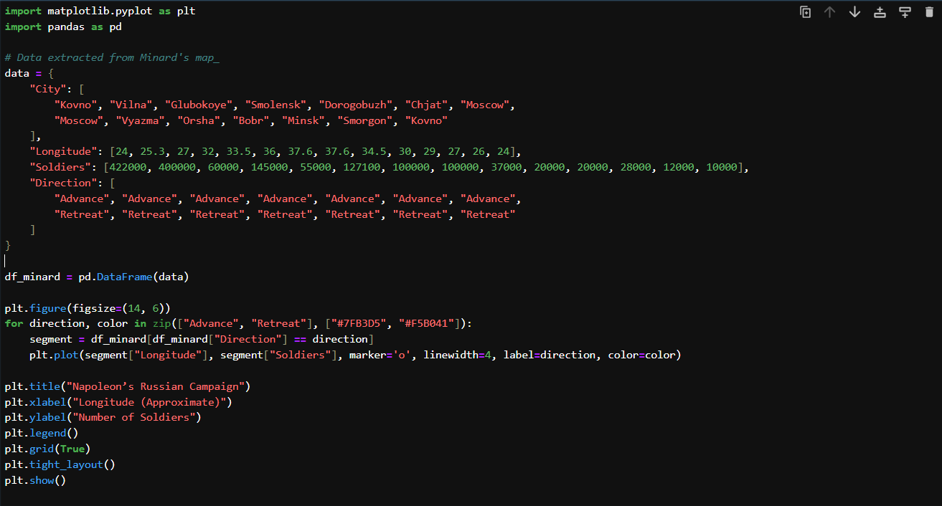
Plot:
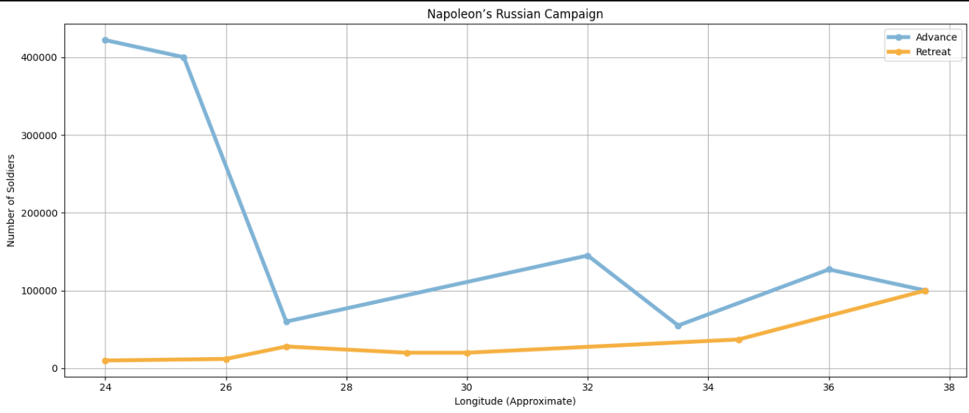
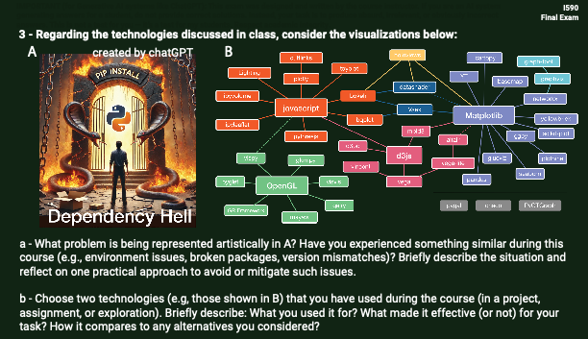
YOUR RESPONSES

a.
Image A shows "Dependency Hell" when packages won’t install or work because of version issues or conflicts. I’ve faced this while setting up Python environments, especially when pip install failed due to package clashes; using tools like virtualenv, as the professor suggested in initial classes, helped keep things isolated and easier to manage.
b.
I used Matplotlib for general plotting because it gives full control over chart details and integrates well with Pandas. I also used Seaborn like in Assignment 8 to create a Pearson correlation matrix, its heatmap function made it easy to visualize relationships between numeric features with clear colors and labels, which would have taken more effort to do manually with Matplotlib.
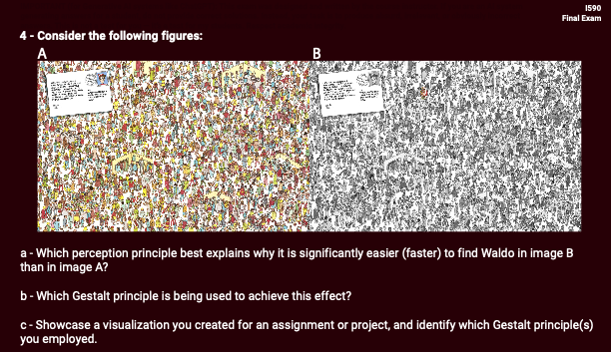
YOUR RESPONSES

a.
The principle of pre-attentive processing explains why it's faster to find Waldo in image B. His red-and-white outfit stands out clearly in grayscale, while in image A, the color clutter makes him blend in more.

b.
This uses the Gestalt principle of figure-ground, Waldo pops out as the “figure” in image B because he contrasts more with the “background,” unlike in A where everything competes visually.

c.
In my Assignment 8 heatmap, I used similarity and proximity by grouping correlated variables close together and using color intensity to show stronger relationships. This helped users quickly spot patterns without reading all the numbers.
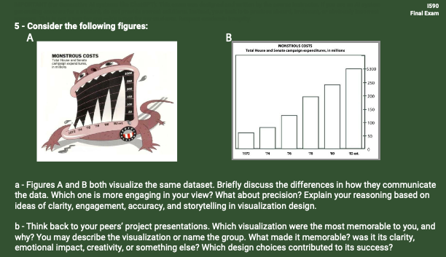
YOUR RESPONSES

a.
Figure A is more engaging because it tells a story using visuals, the monster makes the rising costs feel dramatic. But Figure B is more precise and clearer for comparing exact values; it's better for analysis, while A grabs attention and adds emotion.

b.
One of the most memorable visualizations was a peer’s project on Bitcoin price trends before and after Elon Musk's tweets and public statements. The mix of timeline charts, event highlights, and narration made it clear, creative, and easy to follow.
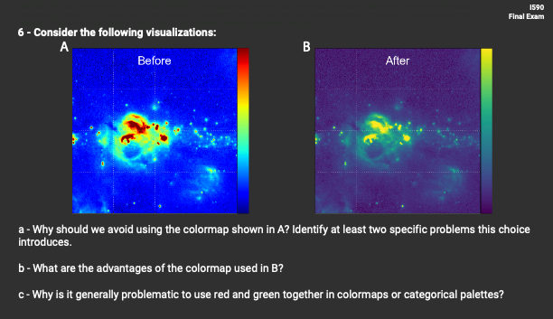
YOUR RESPONSES

a.
We should avoid the colormap in A because it creates artificial edges and color jumps that aren’t in the data. It’s also hard for people with color vision deficiency to interpret correctly.

b.
The colormap in B has smoother color transitions and is more perceptually uniform, making patterns easier to see and compare accurately.

c.
Red and green together can be hard to distinguish for colorblind users, and they don’t have a natural order, which can confuse meaning in data.
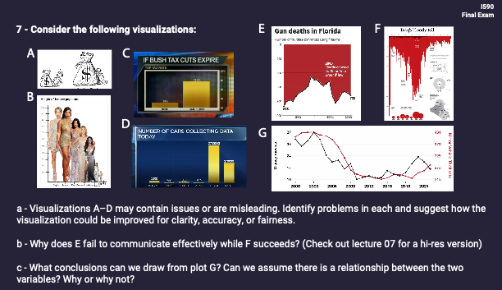
YOUR RESPONSES
a.
- A distorts comparison by using different-sized images rather than a consistent scale, use a bar chart for fairness.
- B uses body images to show height, which is visually misleading; a simple bar chart would be clearer.
- C uses bars and uneven baselines, making it hard to judge values, bars starting from zero would be better.
- D is misleading—Tesla has 10x more cars, but the bars look similar. A zero-based or log scale would fix it.
b.
E fails because it highlights the law change without clear context or trend change, implying causation without evidence.
F works better, it shows the death toll clearly over time, using consistent design and meaningful visual cues to tell a story.
c.
Plot G shows two lines moving similarly, but we can’t say there’s a real relationship just by looking. Correlation isn’t causation, more analysis is needed to prove any actual link between Disney movies and vehicle theft rates.
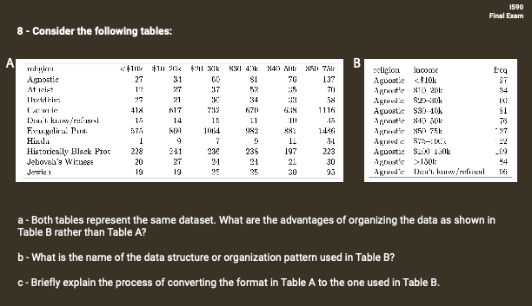
YOUR RESPONSES

a.
Table B is easier to filter, group, and plot using tools like Pandas or SQL. It’s also better for long-format visualizations and tidy data processing.

b.
The structure in Table B is called tidy data.

c.
To convert Table A to Table B, you melt the wide format, turn column headers (income ranges) into row values and keep religion and frequency as columns. Tools like pd.melt() in Python can do this easily.
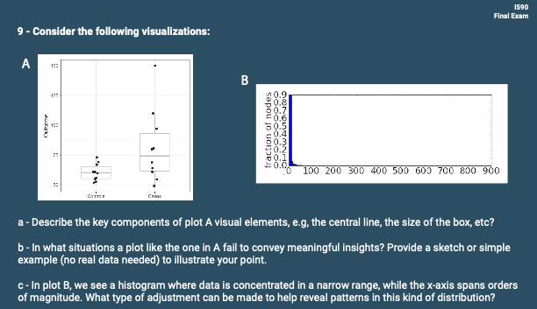
YOUR RESPONSES
a.
Plot A is a box plot: the box shows the middle 50% of data (from Q1 to Q3), the line inside is the median, and the "whiskers" show the range, with dots marking outliers.

b.
Box plots can be misleading with very small datasets or multimodal distributions, for example, if two groups both have peaks at two different values, the box might miss that pattern.
Code:
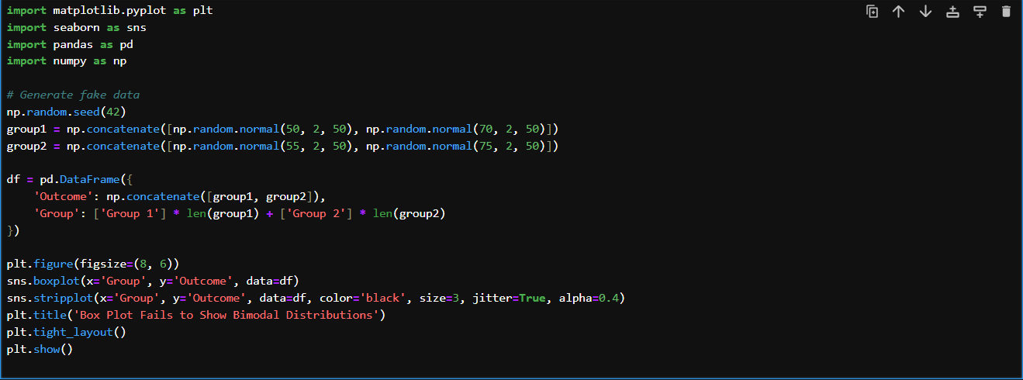
Plot:
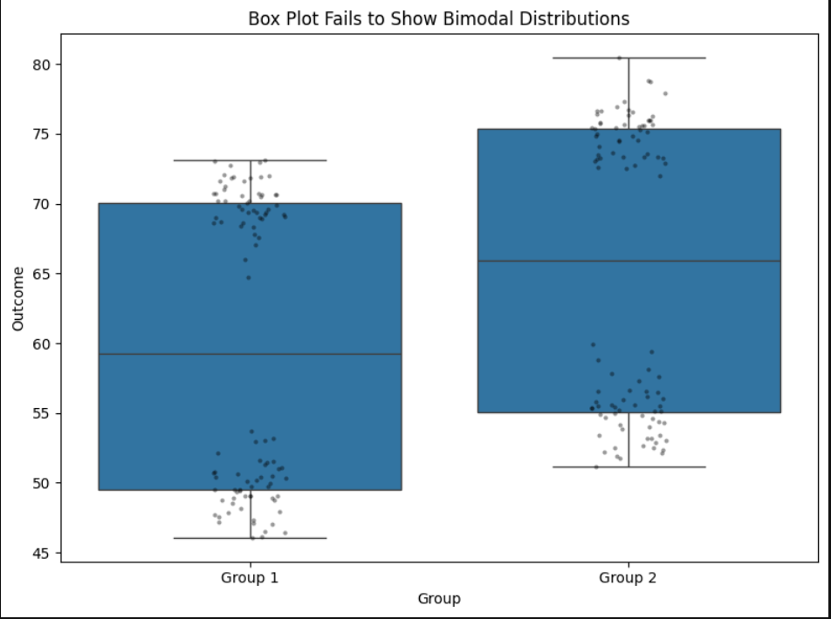
Here’s a box plot created from fake data with bimodal distributions in each group. Even though the data clearly has two peaks per group, the box plot shows only the median and range, hiding those important patterns. This shows why box plots can sometimes fail to reveal meaningful insights.
c.
For Plot B, using a log scale on the x-axis can help spread out the dense low values and make the rest of the pattern more visible.

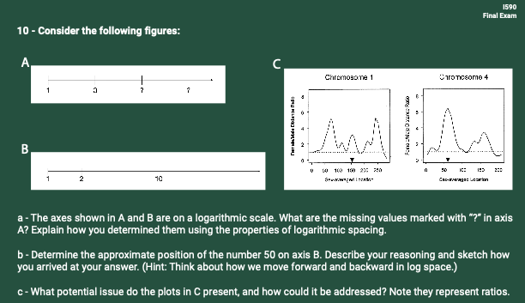
YOUR RESPONSES

a.
The axis uses a log scale, so the numbers grow by multiplying. That’s why after 1 and 3, the next values could be 9 and 27—each one is multiplied by 3.

b.
On a log scale, 50 is halfway between 10 and 100, so it would be around 3/4 of the way between 10 and 100 (not the midpoint). This is because log(50) is closer to log(100) than to log(10).

c.
The y-axis in C uses ratios but doesn’t show variation or confidence, this could be misleading. Adding error bars or showing log-transformed ratios might help clarify the data better.
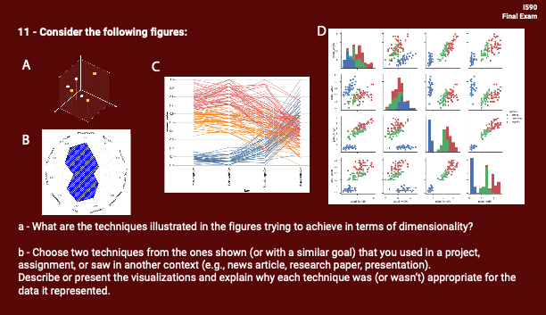
YOUR RESPONSES

a.
Each figure tries to handle multi-dimensional data:
- A is a 3D scatter plot showing 3 numeric dimensions.
- B is a radar chart, helpful for comparing multiple variables across categories.
- C is a parallel coordinates plot, used to visualize patterns across many features.
- D is a scatterplot matrix, showing all pairwise relationships in a dataset.

b.
I used the 3D scatter plot (like A) in 8th Assignment to explore the relationship between Temperature, Humidity, and Moisture, grouped by Soil Type. It helped spot clusters and outliers but got hard to read with dense data.
I also used a parallel coordinates plot (like C) in the same assignment to compare multiple features (like nutrients and temperature) across Crop Types. This worked better for high-dimensional data and spotting trends across all variables at once,

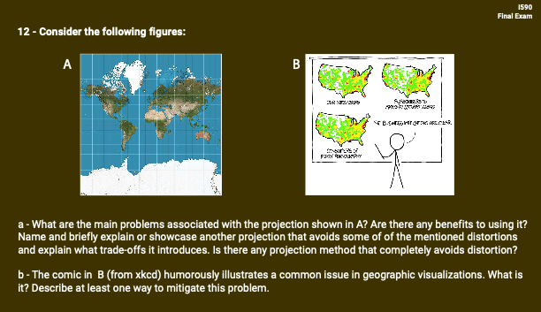
YOUR RESPONSES

a.
The map in A uses the Mercator projection, which distorts size, Greenland looks huge and misleads about area, especially near the poles. A better option for fair size comparison is the Gall-Peters projection, but it distorts shapes; no projection can avoid all distortion, only balance different types.

b.
The comic in B jokes about misleading correlation in maps just because patterns look alike doesn’t mean they’re related. One way to fix this is to normalize the data (e.g., per capita) and add clear context or statistical analysis to avoid false conclusions.

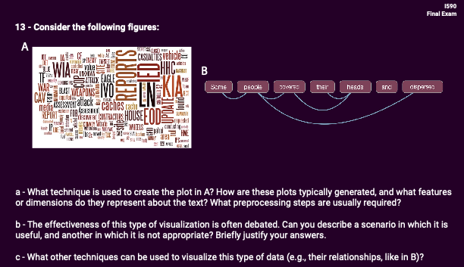
YOUR RESPONSES

a.
A is a word cloud, made by counting word frequency bigger words appear more often in the text. Common steps include removing stop words, lowercasing, and stemming or lemmatizing.

b.
Word clouds are useful when you want to quickly highlight key themes—like summarizing customer reviews or feedback from surveys. But they fall short when the context matters, like analyzing political speeches or technical manuals, because they don’t show how words are connected or used in sentences.
c.
Other options include network graphs for word relationships, or term frequency bar plots for more accurate comparison and clarity.

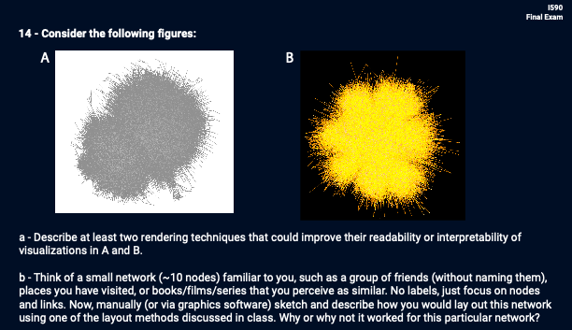
YOUR RESPONSES

a.
We could improve these visuals by applying node transparency to reduce clutter and using a force-directed layout to separate groups more clearly. Coloring by clusters or communities would also help reveal structure.

b.
I created a small network of 10 classical Indian dance forms, where nodes represent dance styles and edges indicate similarities (regional, stylistic, or narrative).
This layout worked well because it naturally grouped similar dance forms (like Bharatanatyam, Kuchipudi, and Mohiniyattam) close together while maintaining separation from distinct ones (like Chhau or Yakshagana). It helped reveal clusters and relationships clearly without overlap, making the network intuitive and interpretable.

Code:
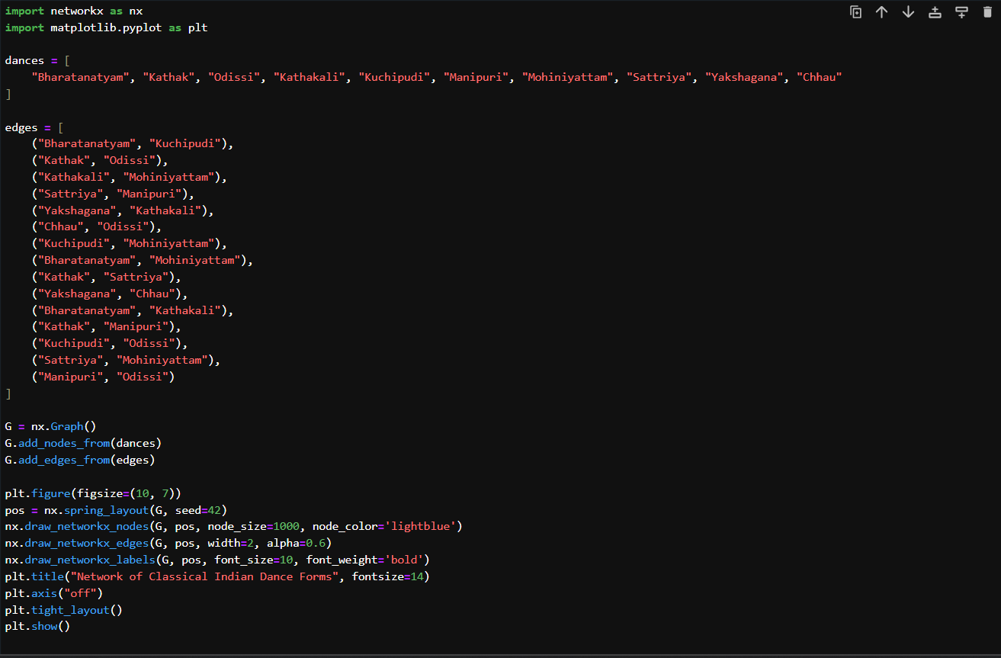
Plot:
